Workspace Reservation Web Application
This web application is designed for reserving workspaces, enabling communication between Teaching Assistants (Tas) and admins, and providing management functionalities for workspace booking. It is built using the MERN stack (MongoDB, Express, React, Node.js) and deployed via Render, with MongoDB Atlas used as the database. The application features real-time communication between the admin and user sides using Socket.io.

Accessing the Application on Render
You can access the live version of the Workspace Reservation web application hosted on Render by following this link: https://workspacereservation-front.onrender.com/
Credentials:
Admin/Coordinator Login
- Email: 24100183@lums.edu.pk
- Password: Admin123.
User Login
1)
- Email: meesum70110@gmail.com
- Password: User123!
2)
- Email: meesum701110@gmail.com
- Password: User123!

Once logged in, you will have access to the respective admin or user/TA functionalities depending on the credentials you use. Explore the platform to manage or reserve workspaces, communicate in real time, and more!

Tech Stack
- Frontend: React.js for user interface development.
- Backend: Node.js with Express.js to manage API routes.
- Database: MongoDB Atlas for managing all user, workspace, and booking data.
- Real-time communication: Socket.io for admin-user communication.
- Deployment: Render for both frontend and backend hosting.

How to Use
Teaching Assistant (TA)
- Login with your user credentials.
- View booked and available workspaces, reserve, or cancel reservations of your ownself.
- Access FAQs for help regarding the application.
Admin (Coordinator)
- Login with admin credentials.
- View booked & available workspaces, reserve, or cancel reservations of any user.
- View user records and manage them; add or delete user profile.
- Communicate with users in real time using Socket.io through FAQs.
Deployment
This application is deployed on Render.
- Frontend: https://workspacereservation-front.onrender.com
- Backend: https://workspacereservation-backend.onrender.com

Features
- User Authentication:
  - Users and admins can log in with their respective credentials.
  - Admin and TA roles are separated, each having access to different functionalities.
  - Passwords are securely stored in the database.
  - Prompts for Incorrect email, Incorrect password.
  - Logout Functionality within Web App. You can log out at any time.
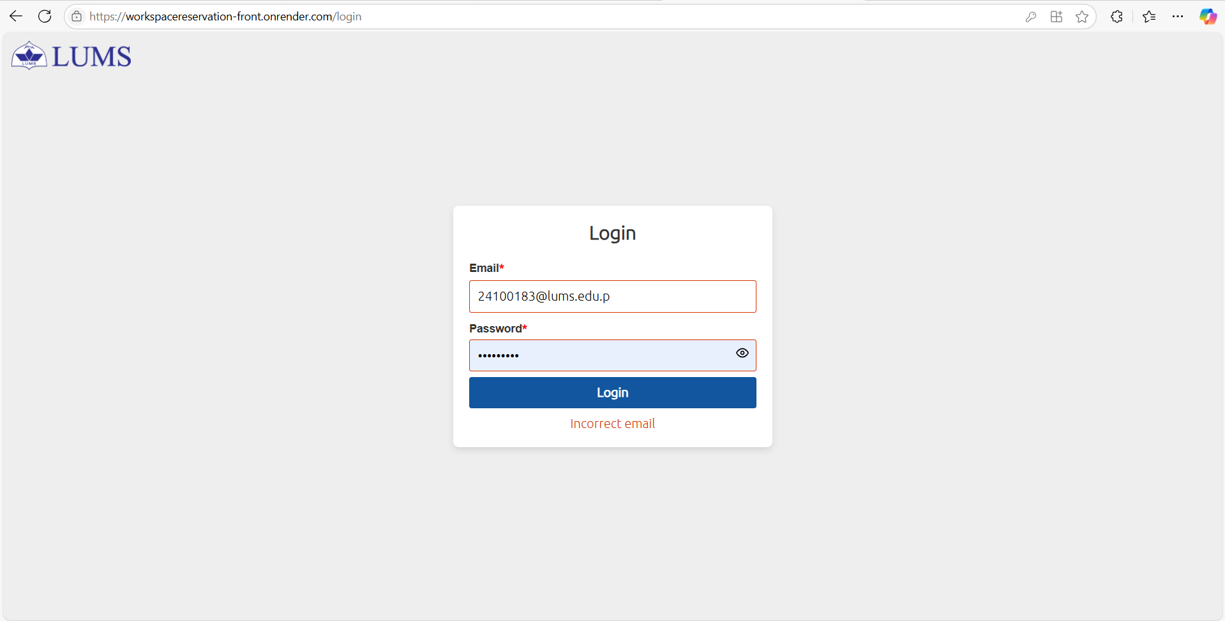

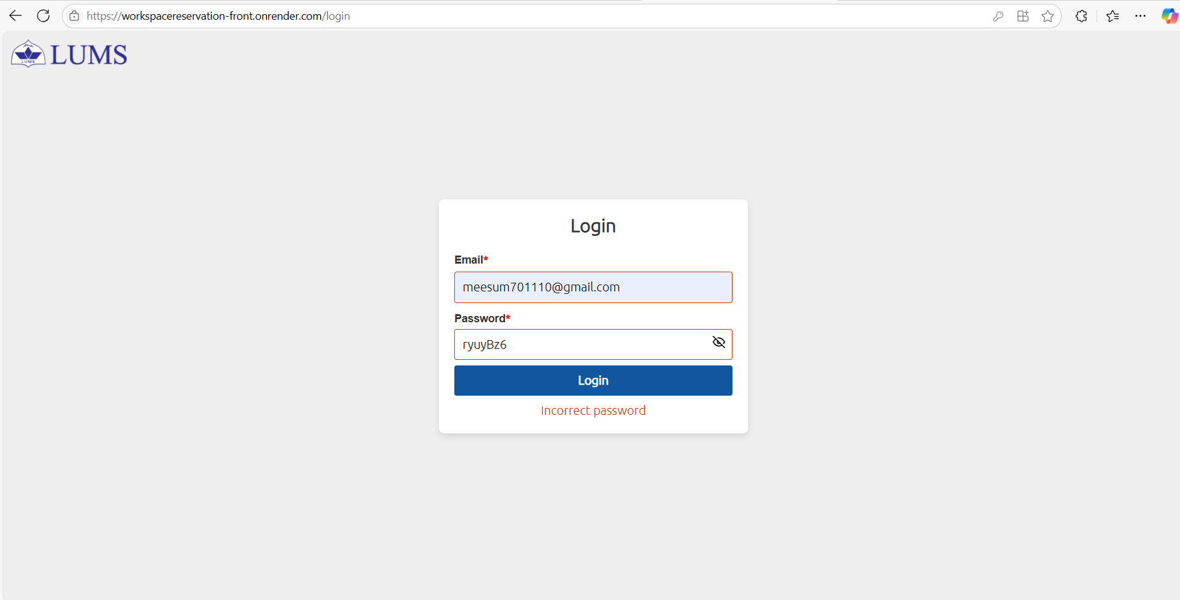

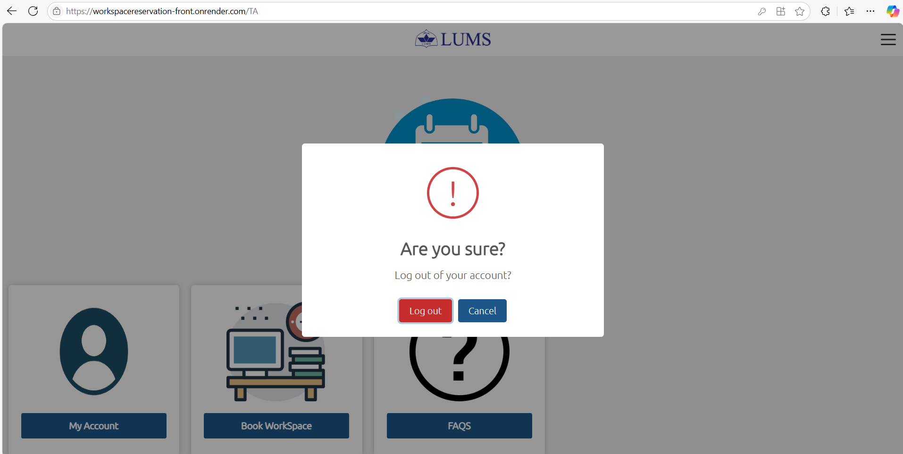

- Admin/Coordinator Dashboard:
  - Admins can view all booked and available workspaces, reserve, or cancel reservations of any user including himself.
  - Admins can view My Account, a list of all users (user records) and search by user role.
  - Admins can manage user records, including adding or deleting accounts.
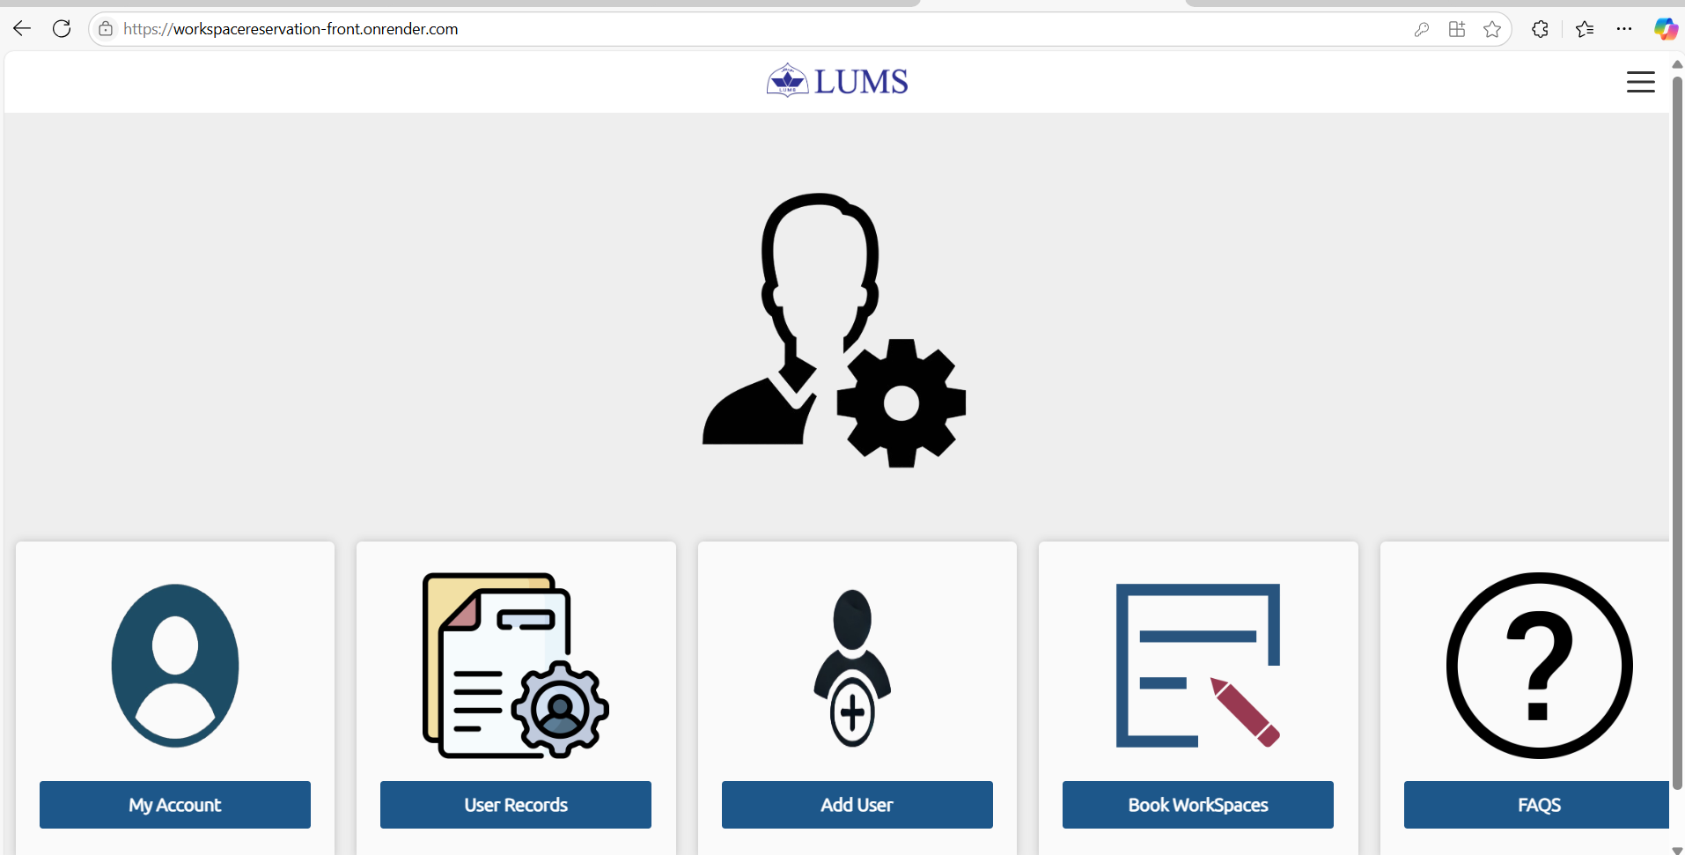

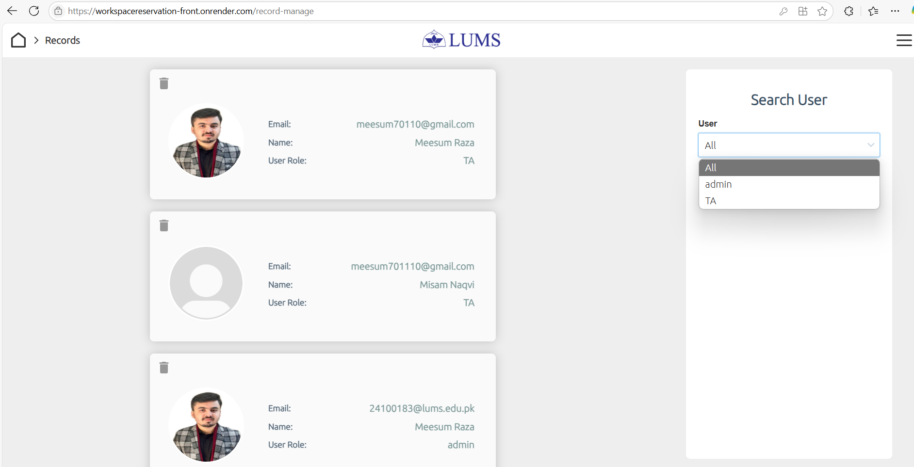

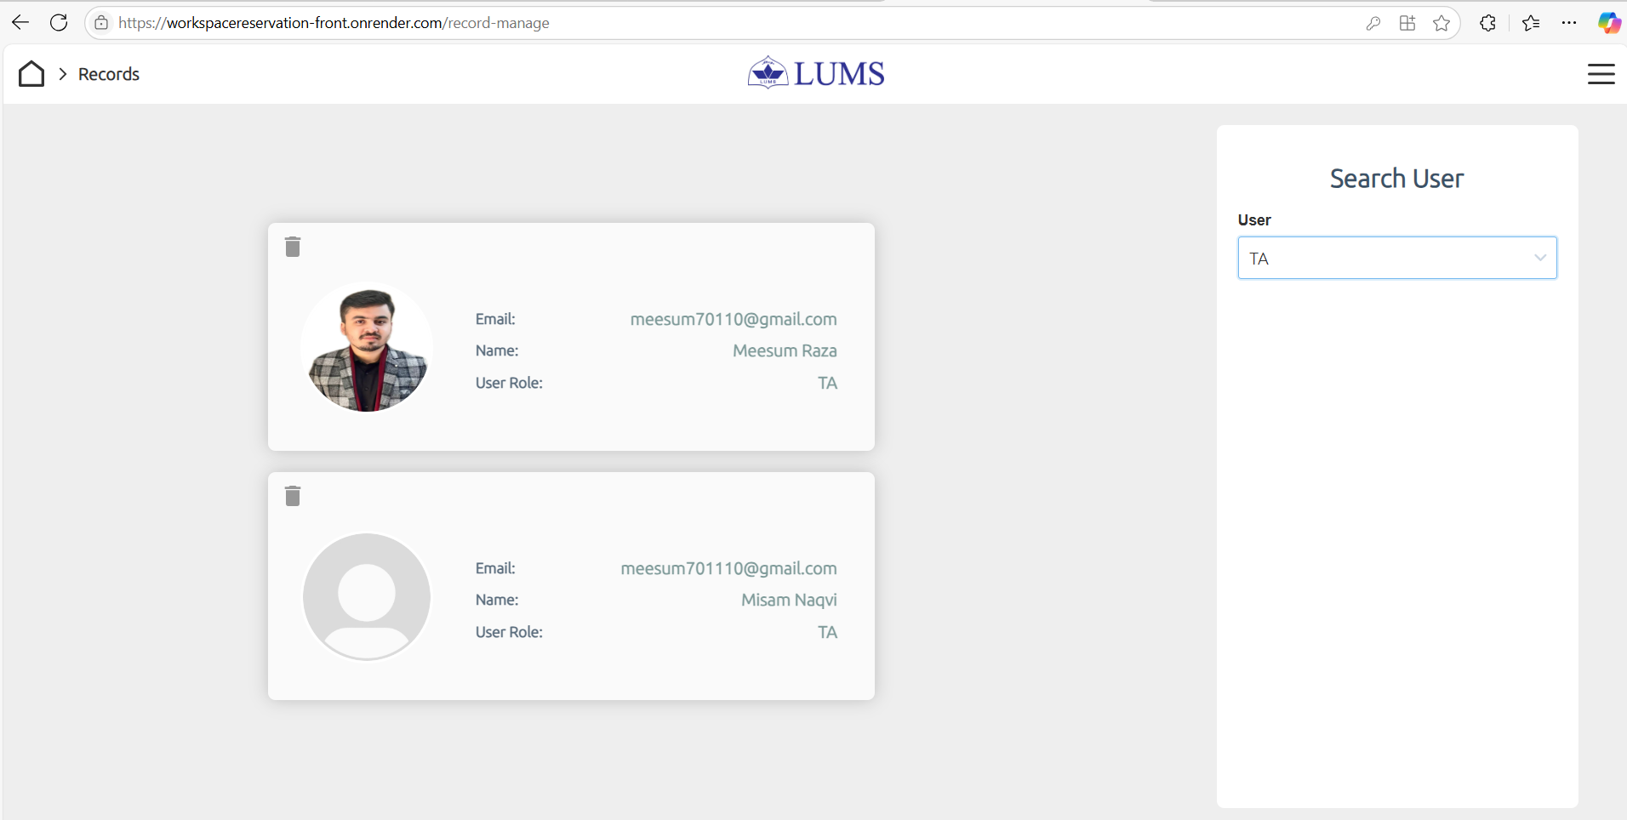

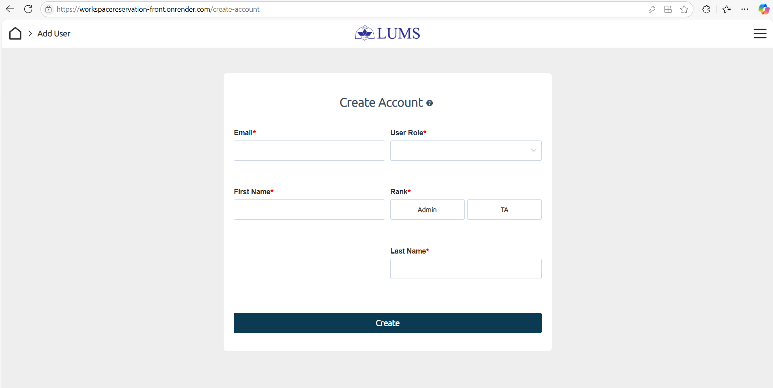

- TA Dashboard:
- User (TA) can Login with user credentials.
- View, and search for available workspaces, reserve, or cancel reservations.
- Access FAQs for help regarding the application.

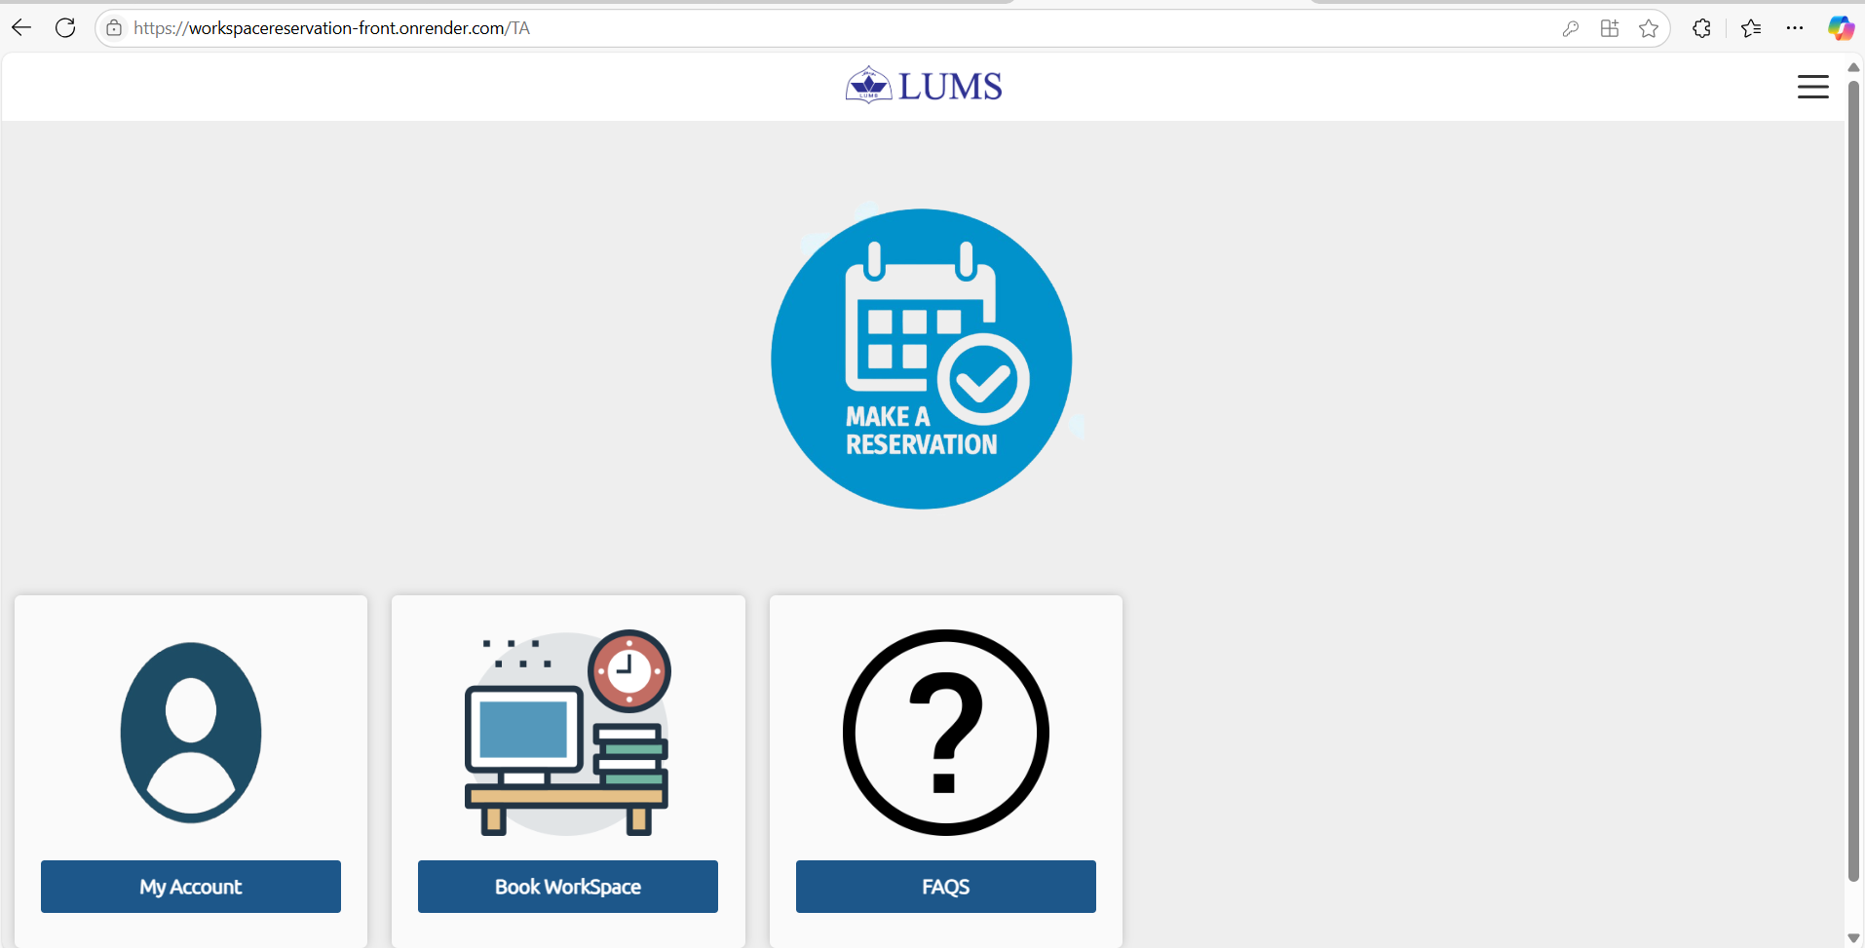

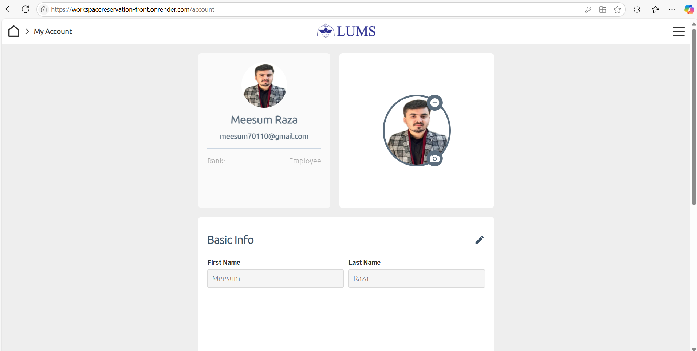

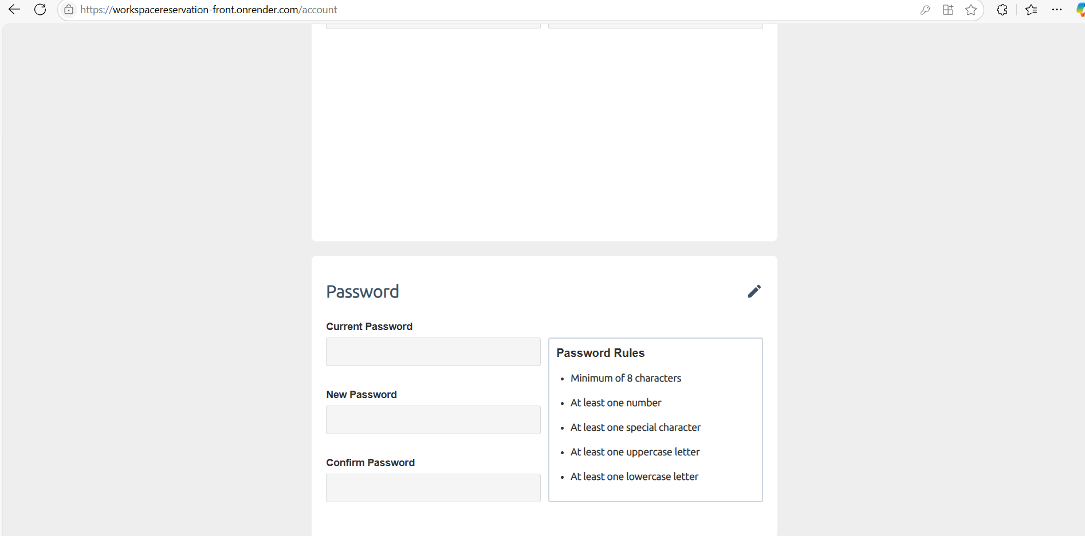

- Workspace Reservation:
  - 4 Rooms: Each room has 26 workspaces in different sizes (1, 2, 4, or 6-seater).
Two User Roles:
  - TAs: Can reserve up to 2 tables.
  - Coordinators: Can reserve multiple tables and manage others’ bookings.
Booking Management:
  - Users can view and cancel their own bookings.
  - Coordinators can manage both their own and others’ bookings.
  - Booking Availability: Reservations are available for the next 7 days.
  - Automatic Deletion: Past reservations are automatically deleted.
  - Search Functionality: Search by date, time, and room number.
  - Table Availability Indication: Reserved tables turn light red; available tables stay green.
  - Conflict Prevention: No double bookings for the same table at the same time..
  - Time: automatically sets to next hour from current time. If it’s above 5pm, then it automatically sets to 9am slot next day in the search bar.

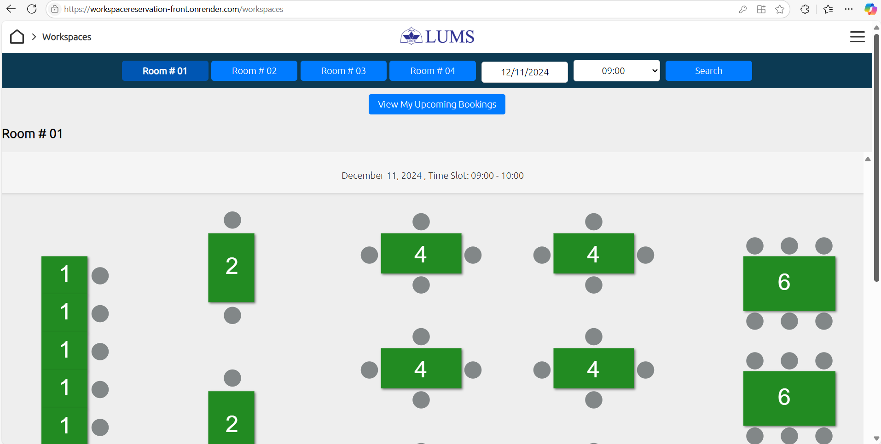
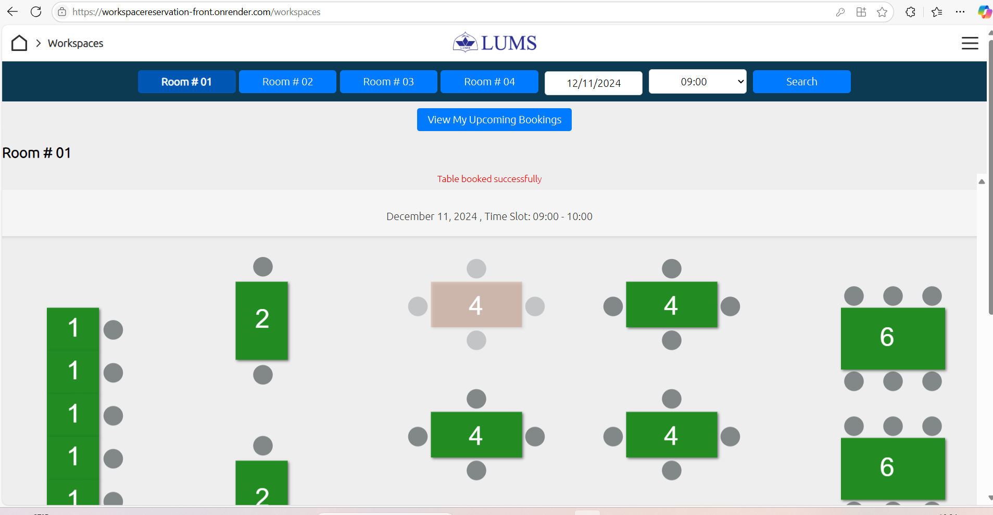

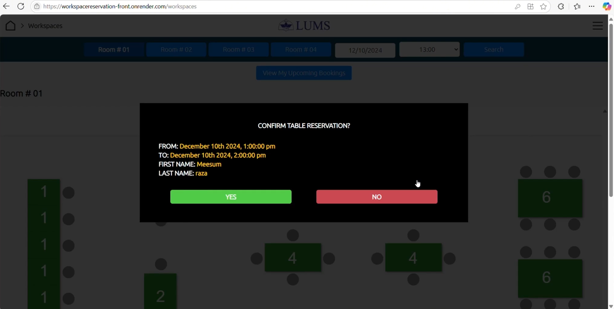

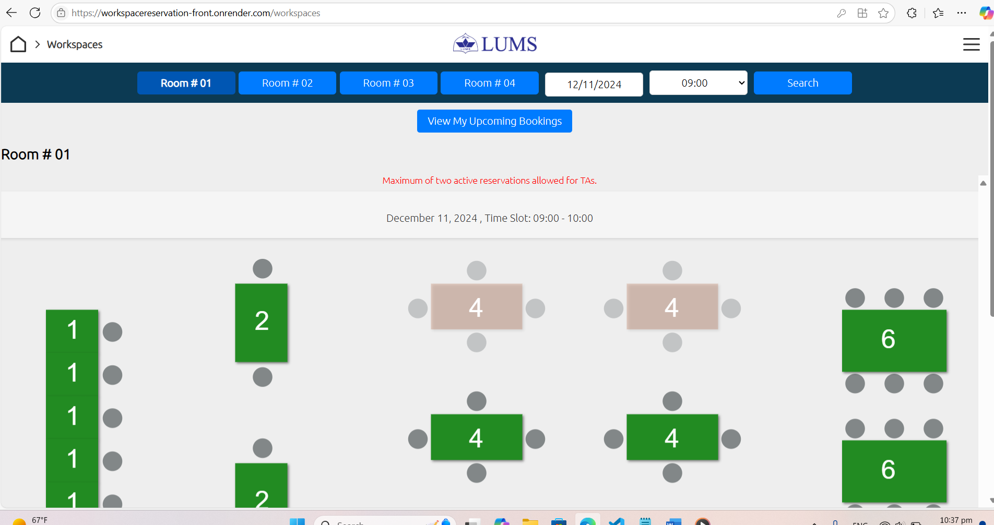

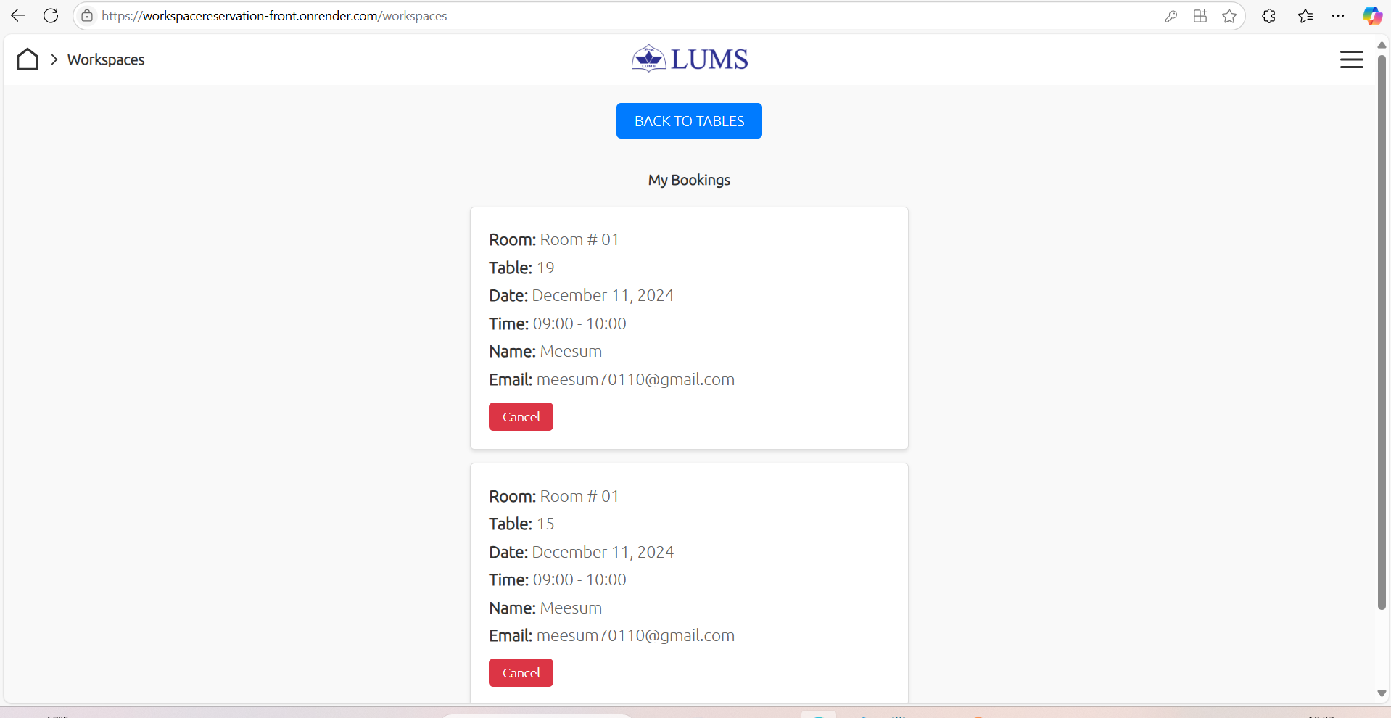

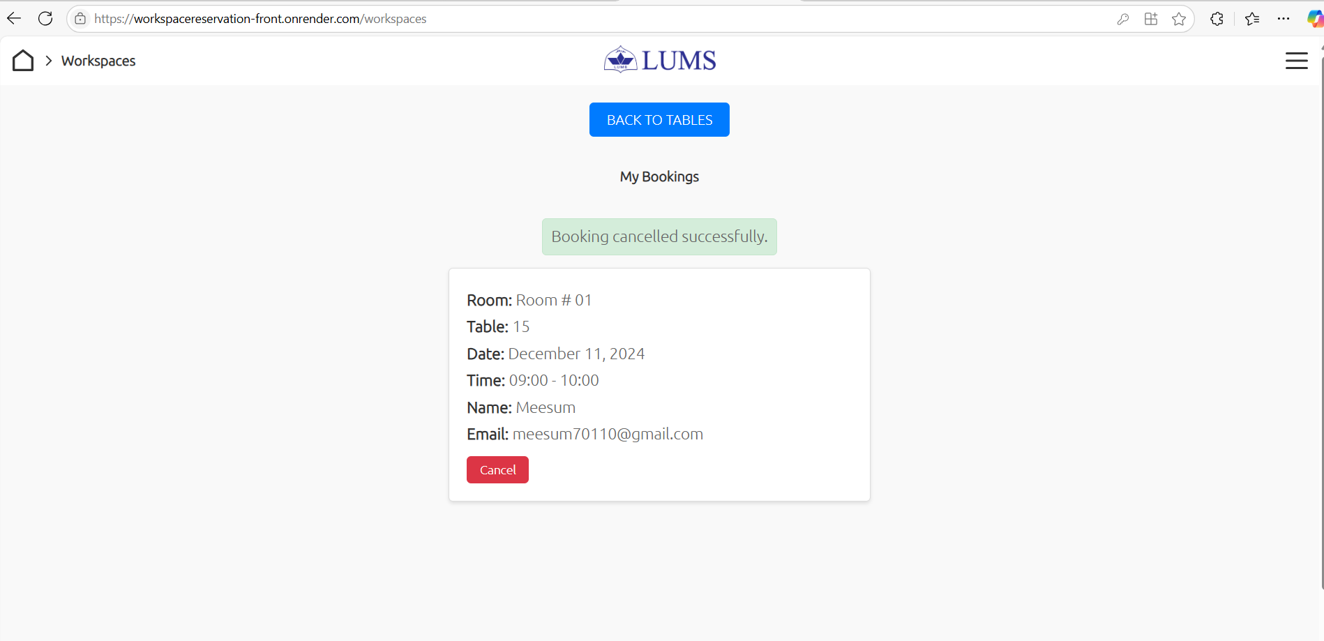

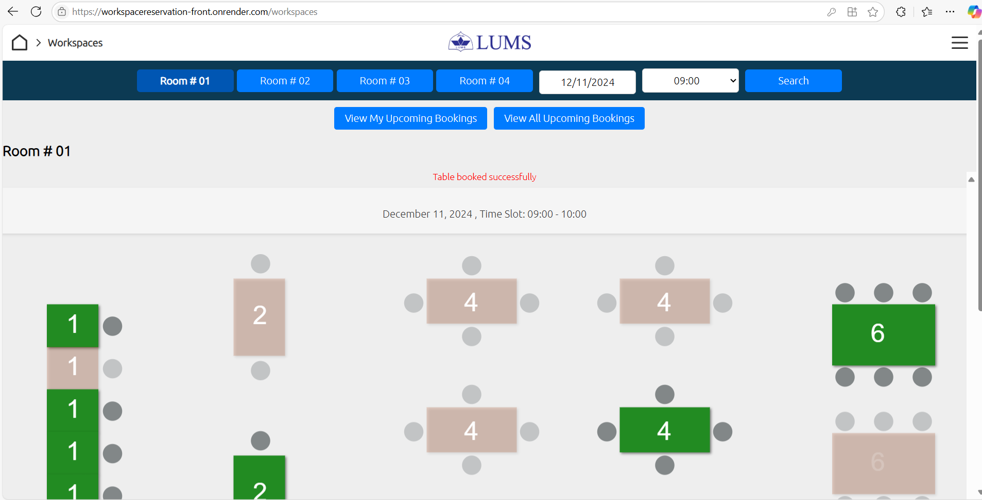

- FAQ Management:
  - Admins can add, or delete frequently asked questions (FAQs) visible to all users.
  - TAs can access FAQs to get quick answers regarding reservations, and cancellations.
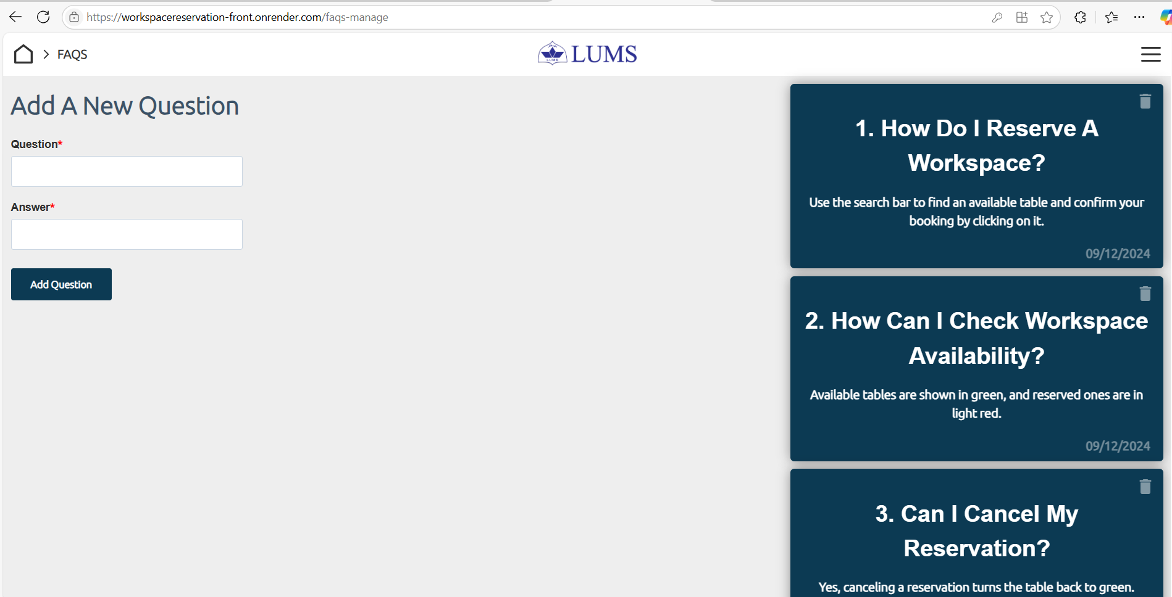

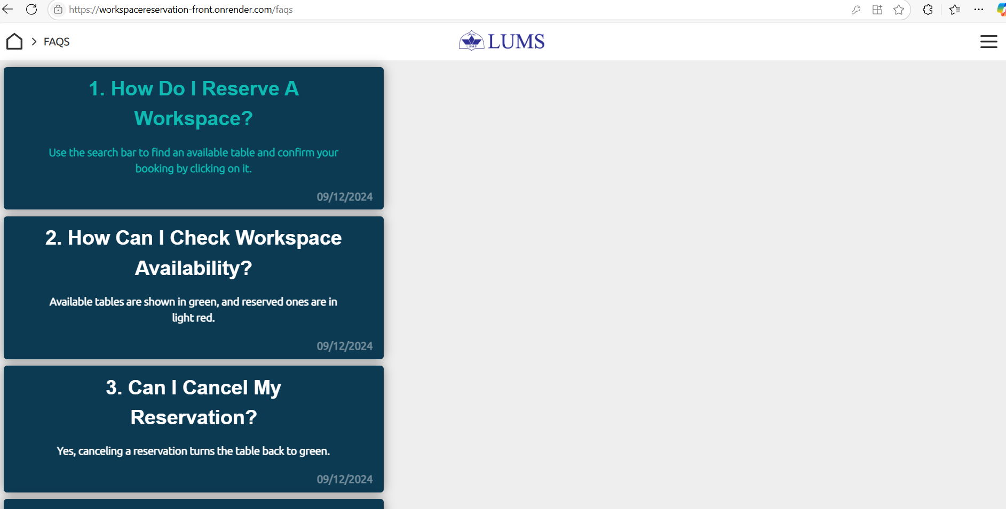

Collapsible Sidebar menu dropdown & Sliding bar (in bottom) for options visibility:

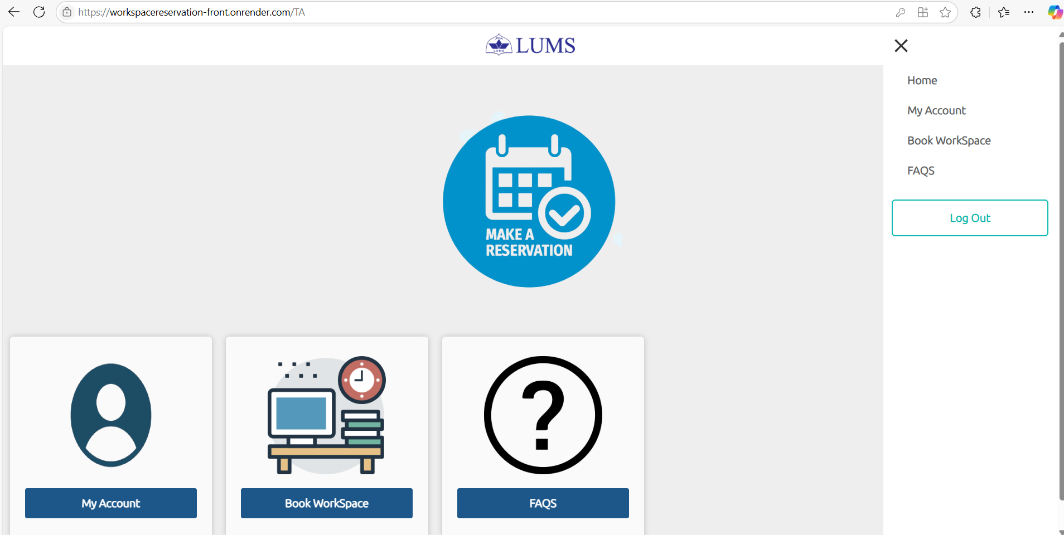

File Structure
P12-UniversityWorkspaceReservationSystem/
│
├── Architecture/
├── Management/
├── Requirements/
├── Reviews/
│
├── client/
│ ├── build/
│ ├── public/
│ ├── src/
│ │ ├── components/
│ │ │ ├── table-workspaces/tables
│ │ │ │ └── components/
│ │ │ │ └── page/booking/
│ │ │ ├── Images/
│ │ │ ├── SharedComponents/
│ │ │ └── (component files like admin.js, login.js, etc.)
│ │ ├── context/
│ │ │ ├── hook/
│ │ │ │ └── useAuthorization.js
│ │ │ └── (context files like authorization.js, socket.js)
│ │ ├── styles/
│ │ │ └── (CSS files like faqs.css, login.css, etc.)
│ │ └── (root files like App.js, index.js)
│
├── server/
│ ├── controllers/
│ │ ├── mailer/
│ │ │ └── sendCredentials.js
│ │ └── (controller files like accountController.js, loginController.js, etc.)
│ ├── middleware/
│ │ └── authorize.js
│ ├── models/
│ │ └── (model files like userData.js, workspaceData.js)
│ ├── routes/
│ │ └── (route files like account.js, login.js, workspace.js)
│ └── (root files like server.js, .env)
│
├── .gitignore
├── LICENSE
├── README.md
├── package.json
├── package-lock.json

